##### <Manager> Add staffs into Project Use Case Diagram

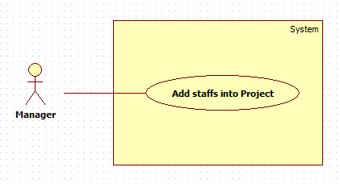

**Figure 1: <Manager> Add staffs into Project Use Case diagram**

**Use Case Specification**

|  |  |  |  |
| --- | --- | --- | --- |
| **USE CASE -1 SPECIFICATION** | | | |
| **Use-case No.** | OTM001 | **Use-case Version** | 1.0 |
| **Use-case Name** | Add staffs into Project | | |
| **Author** | Lê Hải Triều | | |
| **Date** | 03/06/15 | **Priority** | High |
| **Actor:**  Manager  **Summary:**  This use case allows manager to add more staffs into a project.  **Goal:**  Staffs were added into a project  **Triggers**   * Manager clicks on “Add member” button in tab “Member” on Project detail screen.   **Preconditions:**   * User must login with role “Manager”   **Post Conditions:**   * **On Success**: Staffs will be added into project. * **On Failure**: Show error message.   **Main Success Scenario:**   |  |  |  | | --- | --- | --- | | Step | Actor Action | System Response | | 1 | Manager clicks on “Add member” button at Project detail screen. | System opens “Add member” popup:  - Tab “Search”:  + “Staff’s username”: search box with autocomplete, max length: 20  - Tab “Suggest”:  + “Search member…”: search box, max length 50  + “Search”: button  + List staffs: data table with checkbox per record.  + “Add”: button  - “Save”: button  - “Cancel”: button | | 2 | Manager input staff’s username then press Enter. Or check in checkbox of staffs then click on “Add” button. | System will show list of selected staffs. | | 3 | Manager can remove some choices from the list.  [Alternative 1] | Cái này a nghĩ có thể để xuống business rule nhĩ | | 4 | Manager clicks on “Save” button.  [Alternative 1] | System closes popup and updates database.  Shows message: “Project members were added successfully”  [Exception 1] |   **Alternative Scenario:**   |  |  |  | | --- | --- | --- | | No | Actor Action | System Response | | 1 | Manager clicks on “Cancel” button | System closes popup and nothing change. |   **Exceptions:**   |  |  |  | | --- | --- | --- | | No | Actor Action | System Response | | 1 | System cannot update database | Show message: “Something wrong. Please try again.” |   **Relationships:**   * N/A   **Business Rules:**   * A user can join multi projects at the same time. * Because of project-based system, user can be manager of a project and can be staff of another project. * Suggested staffs in autocomplete search box in tab “Search” are all of users have role “Manager” or “Staff”. * Staffs will be showed in data table in tab “Suggest” are users have skills meet project’s need. * Director also can execute this function (for some special situations). | | | |

##### <Manager> Remove staff from Project Use Case Diagram

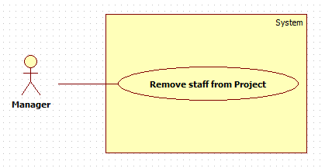

**Figure 1: <Manager> Remove staff from Project Use Case diagram**

**Use Case Specification**

|  |  |  |  |
| --- | --- | --- | --- |
| **USE CASE -1 SPECIFICATION** | | | |
| **Use-case No.** | OTM002 | **Use-case Version** | 1.0 |
| **Use-case Name** | Remove staff from Project | | |
| **Author** | Lê Hải Triều | | |
| **Date** | 03/06/15 | **Priority** | High |
| **Actor:**  Manager  **Summary:**  This use case allows manager to remove staff from a project.  **Goal:**  Staffs were removed from a project  **Triggers**   * Manager clicks on “Remove” button in tab “Member” on Project detail screen.   **Preconditions:**   * User must login with role “Manager”   **Post Conditions:**   * **On Success**: Staff will be removed from project. * **On Failure**: Show error message.   **Main Success Scenario:**   |  |  |  | | --- | --- | --- | | Step | Actor Action | System Response | | 1 | Manager clicks on “Remove” button on staff who manager want to remove from project. | System opens “Are you sure?” popup:  - “Remove”: button  - “Cancel”: button | | 2 | Manager click on “Remove” button.  [Alternative 1] | System closes popup and updates database.  Show message: “This member had been removed successfully”  [Exception 1, 2] |   **Alternative Scenario:**   |  |  |  | | --- | --- | --- | | No | Actor Action | System Response | | 1 | Manager clicks on “Cancel” button | System closes popup and nothing change. |   **Exceptions:**   |  |  |  | | --- | --- | --- | | No | Actor Action | System Response | | 1 | This staff is having some tasks in project (mà task đang trong trạng thái ntn?) | Show message: “This member still having task in project.” | | 2 | System cannot update database | Show message: “Something wrong. Please try again.” |   **Relationships:**   * N/A   **Business Rules:**   * A staff still having task in project cannot be removed. Please close or cancel all tasks of this staff to remove him/her from project. * History of this staff in project will be saved in database. * Director also can execute this function (for some special situations). | | | |

##### <Manager> Create task Use Case Diagram

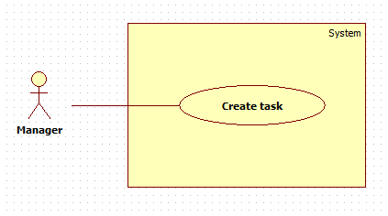

**Figure 1: <Manager> Create task Use Case diagram**

**Use Case Specification**

|  |  |  |  |
| --- | --- | --- | --- |
| **USE CASE -1 SPECIFICATION** | | | |
| **Use-case No.** | OTM002 | **Use-case Version** | 1.0 |
| **Use-case Name** | Create task | | |
| **Author** | Lê Hải Triều | | |
| **Date** | 03/06/15 | **Priority** | High |
| **Actor:**  Manager  **Summary:**  This use case allows manager to create a new task.  **Goal:**  Manager creates a new task.  **Triggers**   * Manager clicks on “Create” button in tab “Member” on Project detail screen.   **Preconditions:**   * User must login with role “Manager”   **Post Conditions:**   * **On Success**: Staff will be removed from project. * **On Failure**: Show error message.   **Main Success Scenario:**   |  |  |  | | --- | --- | --- | | Step | Actor Action | System Response | | 1 | Manager clicks on “Create” button in tab “Member” on Project detail screen. | System opens “Create task” popup:  - “Project name”: textbox, not editable  - “Task name”: textbox, max length: 50 characters, required.  - “Description”: text area, max length: 200 characters, required  - “Assign to”: search box with autocomplete, max length: 20  - “Priority”: checkbox  - “Level”: dropdown-list, data: “Easy”, “Medium”, “Hard”. Default: “Medium”  - “Deadline”: Date time picker, required  - “Create”: button  - “Cancel”: button | | 2 | Input data |  | | 3 | Click on “Create” button  [Alternative 1] | System closes popup and updates (add new record to) database.  Show message: “New task had been created.”  [Exception 1, 2, 3, 4, 5] |   **Alternative Scenario:**   |  |  |  | | --- | --- | --- | | No | Actor Action | System Response | | 1 | Manager clicks on “Cancel” button | System closes popup and nothing change. |   **Exceptions:**   |  |  |  | | --- | --- | --- | | No | Actor Action | System Response | | 1 | Task name is empty | Show message: “Task name is required.” | | 2 | Description is empty | Show message: “Description is required” | | 3 | Deadline is empty | Show message: “Deadline is required” | | 4 | Deadline was selected before system’s date time (ví dụ trường hợp task lúc trước lỡ bị xóa mà nó muốn tạo lại thì sao?) | Show message: “Deadline must be selected after system’s date time” | | 5 | System cannot update database | Show message: “Something wrong. Please try again.” |   **Relationships:**   * N/A nên có extend để chỉ việc nếu chọn assignee ngay trong lúc create thì sẽ thực hiện luôn function “assign task”   **Business Rules:**   * If “Assign to” is empty, status of task will be “New”. * If “Assign to” is a staff’s username, status of task will be “Pending” and task will be assigned to this staff. * Status of task includes: “New”, “Pending”, “In progress”, “Reject”, “Redo”, “Closed”, “Cancelled”. * Created Date of task will be system’s date time at the create task time. * Ended Date of task will be system’s date time at the close task time * Director also can execute this function (for some special situations). | | | |